Project Design Phase-II

Customer Journey Map

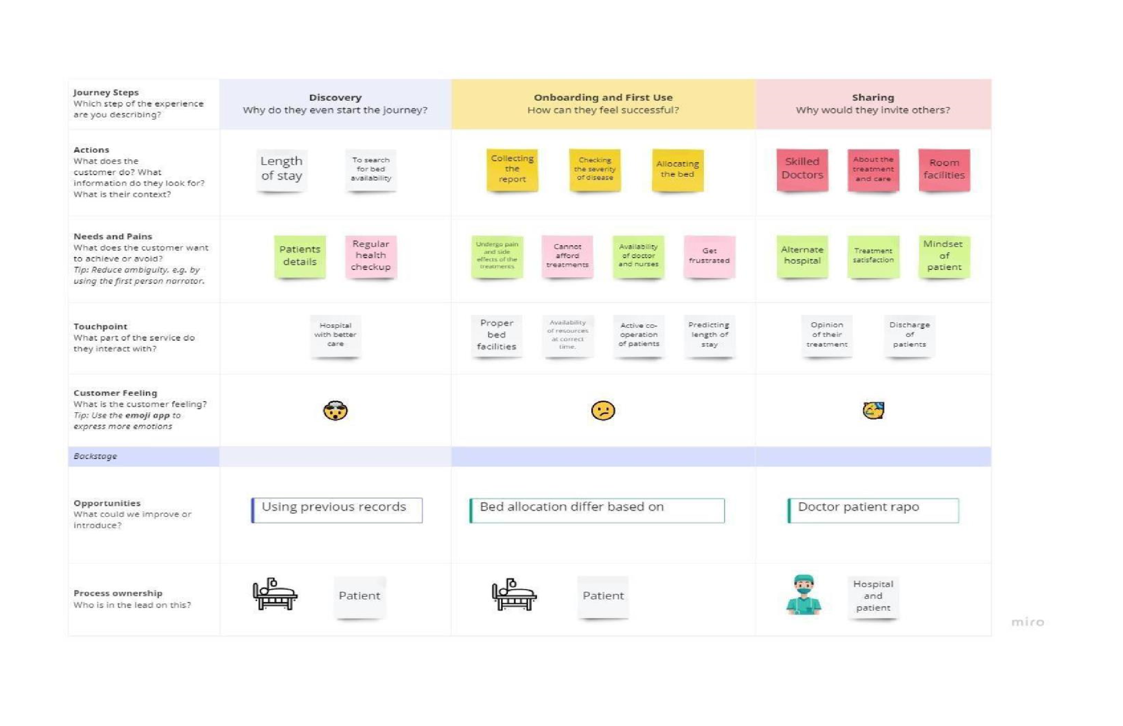

|  |  |
| --- | --- |
| Date | 21 October 2022 |
| Team ID | PNT2022TMID08105 |
| Project Name | Project – Analytics For Hospital Health-Care Data |
| Maximum Marks | 2 Marks |